Heart of Algebra SAT Practice Problem 5 Name_________________________________
Unit 3 Test Day Worksheet (HOA #16) Date: __________________ Hour: _______

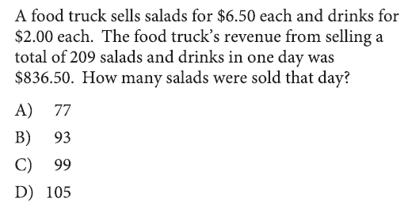
a) What is the problem asking?

b) What information is given?

c) What vocabulary would you need help with?

d) What variables can you use for salads and drinks?

e) How many salads and drinks were sold in one day? Use the variables from part d to create an equation for the number of items sold in one day.

f) How much is one salad? How much is one drink?

g) How much revenue was earned from selling salads and drinks in one day? Use the price per item from part f and the variables from part d to create an equation for the revenue earned in one day.

h) Use your equations from part e and part g to solve a system of equations using substitution or elimination.

i) Do you want the number of salads or the number of drinks as an answer?

j) Answer_______________________________

