Heart of Algebra SAT Practice Problem 4 Name_________________________________
Unit 3 Quiz Day Worksheet (HOA #10) Date: __________________ Hour: _______

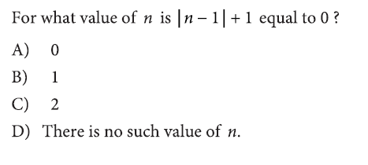
1) What is the problem asking?
$$For what value of n is \left|n-2\right|+2 equal to 0?$$

2) What information is given?

3) What vocabulary would you need help with?

4) What do you know about absolute values? Can an absolute value ever be negative?

5) Using answer choices A, B, and C, plug each value in for n and calculate. Do any of these choices make the expression equal to 0?

6) Answer:_________

7) Explain why your answer choice is correct.

