Unit 7: Modeling with 3-D Figures Name:_______________________
Day 9 Volume Formulas Activity Date: ______________Hour: ___
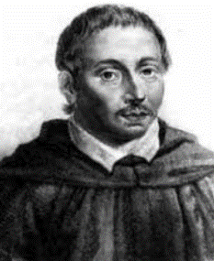
Bonaventura Francesco Cavalieri (1598-1647)
Cavalieri’s Principle
The volumes of two solids are equal if the areas of the corresponding sections drawn parallel to some given plane are equal.

The best way to describe Cavalieri’s Principle is using stacks of objects. Look at the two stacks of CDs on the right. Assuming the two stacks have congruent length, widths, and heights, what can you conclude about the volumes of the two stacks of CDs?
____________________________________________________
_____________________________________________________
When the second stack of CDs is moved so the height is not the edge of the height of the prism, how do you think that affects the volume?
__________________________________________
_______________________________________
_______________________________________
Volumes of Cones vs. Cylinder
Label the height, H, and radius, r, on both diagrams below.
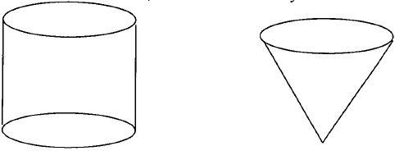

- If the cylinder was full of water and you poured it into the cone, how many times would you be able to fill the cone?

- If the cone was filled with water, how many times would you have to fill and pour it into the cylinder for the cylinder to be completely full?

Complete the formulas below.

Volume of a Cylinder Volume of a Cone

V= V=

- What is the relationship between these two volumes?

Volumes of Prisms vs. Rectangular Pyramids
Label the height, H, length, l, and width, w, on both diagrams below
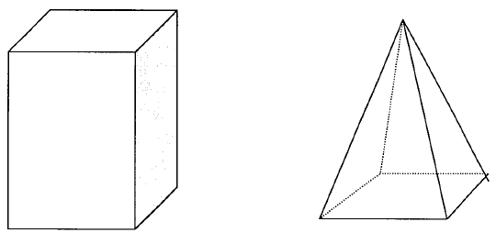

- If the prism was full of water and you poured in into the pyramid, how many times would you be able to fill the pyramid?

- If the pyramid was filled with water, how many times would you have to fill and pour it into the prism for the prism to be completely full?

Complete the formulas below.

Volume of a Prism Volume of a Pyramid

V= V=

- What is the relationship between these two volumes?

Homework: Day 9 Worksheet
Unit 7: Modeling with 3-D Figures Name:_______________________
Day 9 Volume Formulas Worksheet Date: ______________Hour: ___

SHOW ALL WORK FOR FULL CREDIT
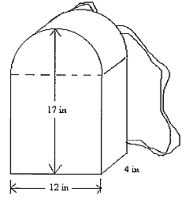
- Approximate the volume of the backpack at the right.

Explain how you separated the backpack and used volume formulas to find the entire volume of the backpack.

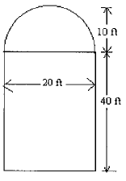
- Find the volume of the grain silo shown at the right that has
a diameter of 20ft and height of 50 ft.

Explain how you separated the silo and used volume formulas to find the entire volume of the backpack.

- The diameter of a baseball is about 1.4 inches. How much rubber is needed to fill the baseball?

- The volume of a cylindrical watering can is 100 cm³. If the radius is doubled, then how much water can the bigger, newer can hold?

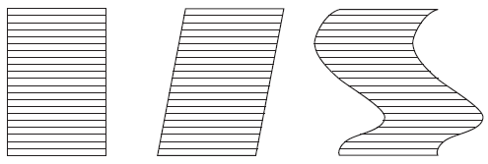
- The figures below can be covered by equal numbers of straws that are all cut to the same length. Describe how Cavalieri’s Principle could be adapted to compare the areas and volumes of these figures.

