**Unit 7: Modeling with 3-D Figures Name:\_\_\_\_\_\_\_\_\_\_\_\_\_\_\_\_\_\_\_\_\_\_\_**

**Day 8 Volumes of Spheres (PH 10-7) Date: \_\_\_\_\_\_\_\_\_\_\_\_\_\_Hour: \_\_\_**

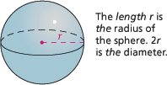

A [***sphere***](https://www.pearsonsuccessnet.com/snpapp/iText/products/0-13-037878-X/Ch10/10-07/PH_Geom_ch10-07_Obj1_voc5.html) is the set of all points in space equidistant

from a given point called the [center.](https://www.pearsonsuccessnet.com/snpapp/iText/products/0-13-037878-X/Ch10/10-07/PH_Geom_ch10-07_Obj1_voc6.html)

**Volume of a Sphere**

***V* = *πr*3**

**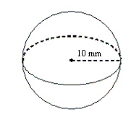Example 1:** Find the volume of the sphere.

**Example 2**: Find the volume of the sphere.

**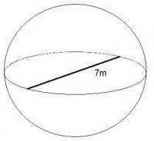**

**Example 3**: The volume of a sphere is 4200 ft3. Find its diameter to the nearest tenth.

**Homework:** Pages 561 – 564 #12 – 17, 22 a and b, 23, 24 and Check Point Quiz #1 – 9 all

Day 8 Homework:





**Check Point Quiz**

**Find the volume of each figure to the nearest tenth.**

|  |  |  |  |  |
| --- | --- | --- | --- | --- |
| 1.  **TT_PH_EN_MA_GM_2004_10/PH_MA_GM04_10_07_564_1.gif** | **TT_PH_EN_MA_GM_2004_10/PH_MA_GM04_10_07_564_2.gif2.** | **TT_PH_EN_MA_GM_2004_10/PH_MA_GM04_10_07_564_3.gif3.** | **TT_PH_EN_MA_GM_2004_10/PH_MA_GM04_10_07_564_4.gif4.** | **TT_PH_EN_MA_GM_2004_10/PH_MA_GM04_10_07_564_5.gif5.** |
| **6.**  **TT_PH_EN_MA_GM_2004_10/PH_MA_GM04_10_07_564_6.gif** | **TT_PH_EN_MA_GM_2004_10/PH_MA_GM04_10_07_564_7.gif7.** | **TT_PH_EN_MA_GM_2004_10/PH_MA_GM04_10_07_564_8.gif8.** | **TT_PH_EN_MA_GM_2004_10/PH_MA_GM04_10_07_564_9.gif9.** |  |