Unit 6: Circles Name:_______________________
Day 7 Tangent Lines (PH 11-1) Date: ______________Hour: ___

Theorem 11 – 3
The two segments that are tangent to a circle
from a point outside the circle are congruent.

Example 1: $\overline{QS }$and $\overline{QT }$are tangent to ʘO at points S and T, respectively. Give a convincing argument why the diagonals of quadrilateral QSOT are perpendicular.
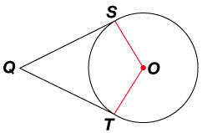

Example 2: ʘC is inscribed in quadrilateral XYZW. Find the perimeter of XYZW.
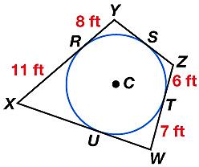

The polygon above is said to circumscribe the circle. It is tangent to the circle along each edge of the figure. The circle is said to be inscribed in the polygon. It is inside and connects at the points of tangency.
Example 3: Is the polygon inscribed in or circumscribed about the circle?

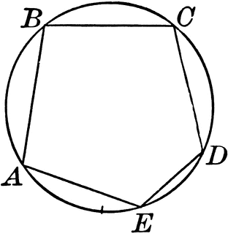
a. b. 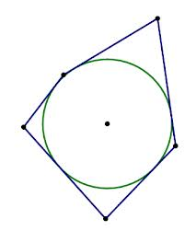

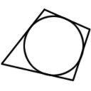

c. d.

Example 4: Find the radius of the circle inscribed in a right triangle with sides 3in, 4in, and 5 in.

Homework: pages 586 – 587 # 13 – 22 all, and 31

