Unit 7: Modeling with 3-D Figures Name:_______________________
Day 7 Solids of Revolution Date: ______________Hour: ___

Investigation:

Place a square sticky note on the end of a pencil as shown in the diagram. What happens when the pencil is rotated quickly between the palms of your hand?

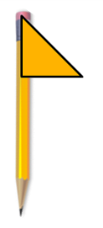
What figure do you see?

Now, cut the square sticky note on a diagonal to create a right triangle and repeat the procedure.
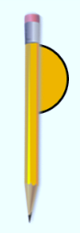

What figure do you see this time?

What figure would be produced if half of a circle was rotated on the end of a pencil?

A plane region that revolves completely about a line sweeps out what is known as a solid of revolution. The investigation above illustrates this concept. It is further illustrated using an applet found at the following website.

http://www.ixl.com/math/geometry/solids-of-revolution

Example 1: a) Sketch the figure bounded by the equations x = 0, y = 0, x = 3, and y = 2.

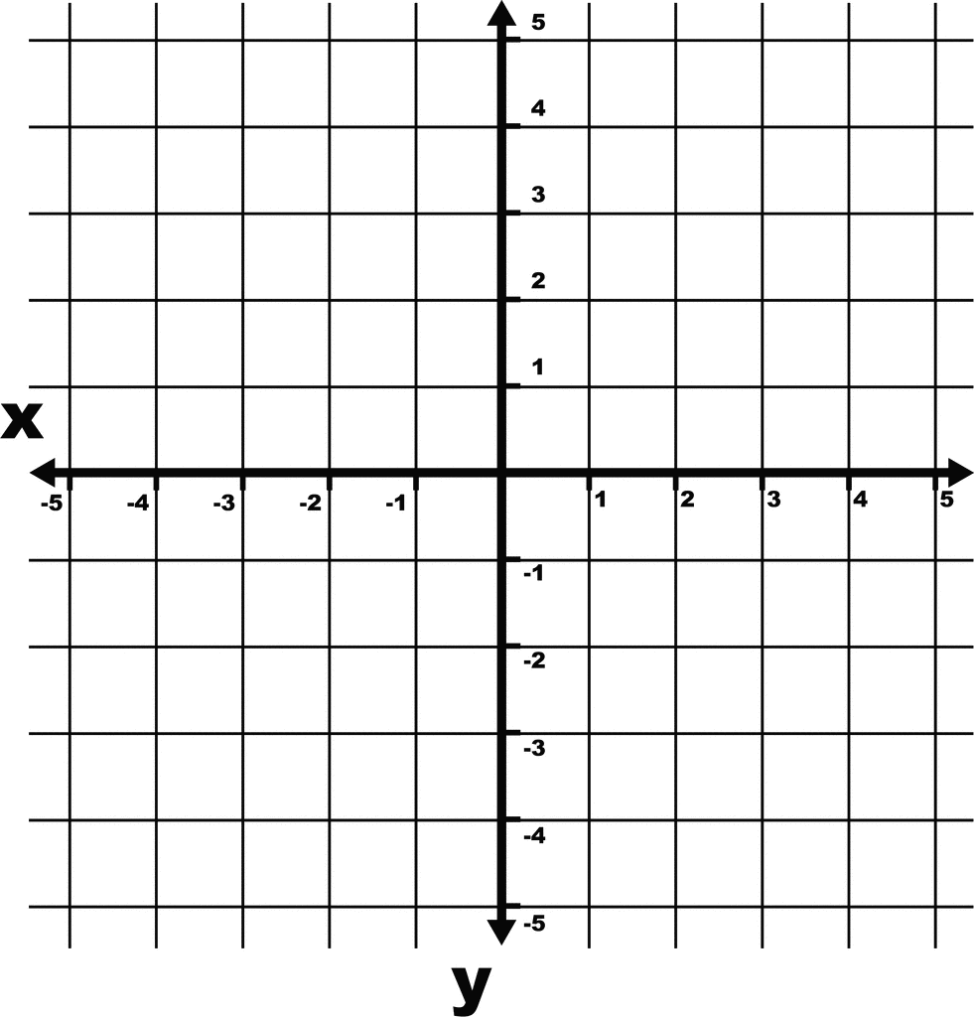
b) Determine the perimeter of the region.

c) Determine the area of the region.

d) Draw a picture of the region being revolved
about the x-axis.

e) What geometric figure is formed by revolving
the region about the x-axis?

f) Determine the volume of the geometric solid.

Example 2: a) Sketch the figure bounded by the equations x = 0, y = 3, and y = x.

b) Determine the perimeter of the region.

c) Determine the area of the region.

d) Draw a picture of the region being revolved about
the y-axis.

e) What geometric figure is formed by revolving the region about the y-axis?

f) Determine the volume of the geometric solid.

g) If the region were revolved about the x-axis, would the volume be greater than, less
than, or equal to the volume formed by revolving about the x-axis? Justify your answer.

Example 3: a) Sketch a figure bound by x = 1, x = 3, y = 2, and y = 4.
b) What geometric figure is formed by revolving the
region about the x-axis?

c) What is the volume of this figure?

Homework:
p. 515 #26 – 28
p. 533 #27 – 30 (Describe the solid-do not find surface area)
p. 542 #46 – 49 (Describe the solid-do not find surface area)
p. 549 #29 – 32 (Find the volume and describe the solid)
p. 556 #29 – 32 (Find the volume and describe the solid)

