Unit 7: Modeling with 3-D Figures Name:_______________________
Day 6 Volume of a Pyramid and Cone (PH 10-6) Date: ______________Hour: ___

Volume of Pyramid: _____________ Volume of Cone: ______________

Example 1: Find the volume of the cone to the nearest tenth.
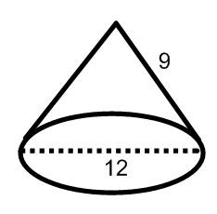

Example 2: Find the volume of the triangular pyramid.
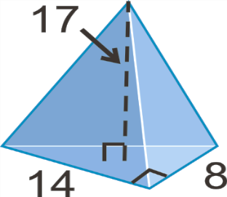
.

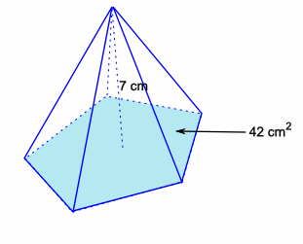
Example 3: Find the volume of the pentagonal pyramid.

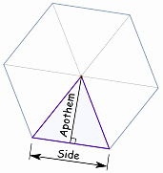
Area of a Regular Polygon:
Area = ½ ∙Perimeter∙ Apothem
A = ½ ∙ P ∙ a

Example 4: Find the volume of the pentagonal pyramid. Each side of the pentagon is 7.3 in.
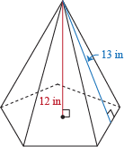

Example 5: Find the volume of the hexagonal pyramid. Each side of the hexagon is 6 cm.
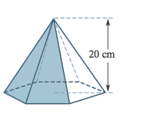
.

Homework: Day 6 KUTA Worksheet

