Unit 6: Circles Name:_______________________
Day 6 Tangent Lines (PH 11-1) Date: ______________Hour: ___

A tangent to a circle is a line in the plane of the circle that intersects
the circle in exactly one point.

The point where the circle and tangent intersect is called the point of tangency.

Theorem 11-1
If a line is tangent to a circle, then the line is perpendicular to the radius drawn to the point of tangency.

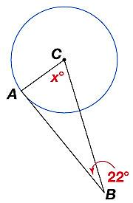
Example 1: $\overset{⃡}{BA}$ is tangent to ʘC at point A. Find the value of x.

Example 2: A belt fits tightly around two circular pulleys, as shown below. Find the distance between the centers of the pulleys. Round your answer to the nearest tenth.
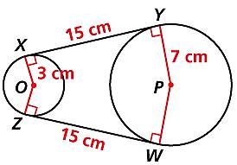

Theorem 11 – 2
If a line in the plane of a circle is perpendicular to a radius at its endpoint on the circle, then the line is tangent to the circle.

Example 3: ʘO has radius 5. Point P is outside ʘO such that PO = 12, and point A is on ʘO such that PA = 13. Is PA tangent to ʘO at A? Explain.
Sketch a picture:

Explain:

Homework: Page 586 #1 – 12 all

