Unit 7: Modeling with 3-D Figures Name:_______________________
Day 5 Volume of a Pyramid and Cone (PH 10-6) Date: ______________Hour: ___

Review: Use the Pythagorean Theorem to find the value of the variable.

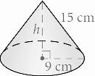
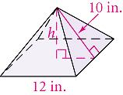
a. b.

A pyramid is a figure that has a polygon for its base and triangles for each of its sides.
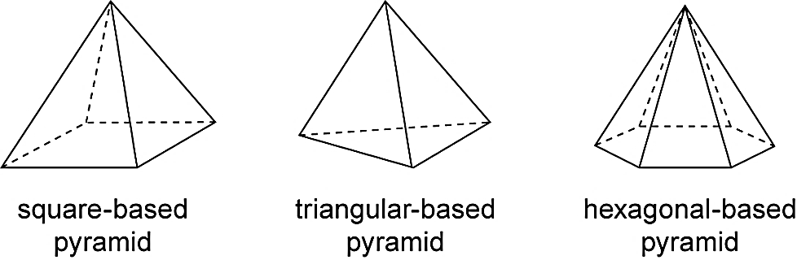

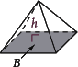
Volume of a Pyramid
Volume = $\frac{1}{3}$ Base Area ∙ Height
V = $\frac{1}{3}$BH

Example 1: Find the volume of the rectangular pyramid.
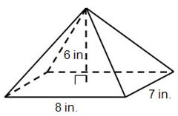

Example 2: Find the volume of a square pyramid with base edges 15 cm and height 22 cm.

Slant height in a pyramid or a cone is the distance from the apex to the base along a side.
Example 3: Find the volume of a square pyramid with base edges 16 m and slant height 17 m.
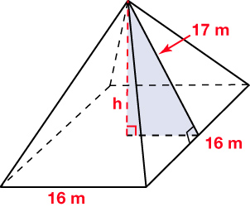

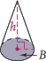
Volume of a Cone
V = $\frac{1}{3}$B ∙ H
V = $\frac{1}{3}$πr² ∙ H

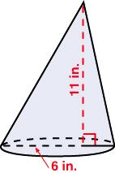
Example 4: Find the volume of the cone in terms of π.

Example 5: An ice cream cone is 7 cm tall and 4 cm in diameter. About how much ice cream can fit entirely inside the cone? Find the volume to the nearest whole number.

Homework: Practice 10-6 Worksheet

