Unit 3 Linear Equations Name: ______________________________
Day 5 Group Activity Date: ___________________ Hour: _____ Solving Systems Review
- Imagine that your friends are planning a wonderful vacation trip to the beach. You will need to rent a car and are comparing different prices.
- Centerprise charges a flat fee of $50 and an additional $2 per mile driven.
- Wertz charges a flat fee of $70 and an additional $1 per mile driven.

- Write equations to model the cost of renting a car from:  Centerprise  Wertz | X Y  0  10  20  30  - Complete a table of values for each equation.  CENTERPRISE WERTZ  X Y  0  10  20  30
- Graph the equations on the same graph.  Use two different colors.  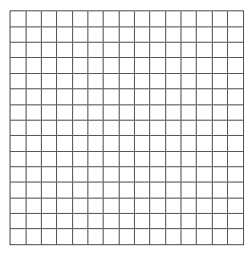 | - Estimate the intersection by looking at the graph.  - What does the intersection represent? Use a complete sentence.  - Verify the solution algebraically. Does it make sense?
- For how many miles would it be better to rent from Wertz? For Centerprise?

Use a system of equations to model each situation. Solve by any method.
2. The sum of two numbers is 30. The sum of the larger number and three times the smaller number is 54. Find the numbers.

3. Shopping at Savers Mart, Lisa buys her children four shirts and three pairs of pants for $85.50. She returns the next day and buys three shirts and five pairs of pants for $115.00. What is the price of each shirt and each pair of pants?

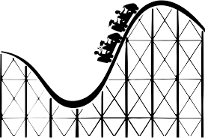
4. An amusement park charges admission plus a fee for each ride. Admission plus two rides costs $10. Admission plus ﬁve rides cost $16. What is the charge for admission and the cost of a ride?

Homework: Unit 3 Day 1 – 5 Review Packet

