**Unit 7: Modeling with 3-D Figures Name:_______________________**

**Day 4 Volume of a Cylinder (PH 10-5) Date: ______________Hour: ___**

**Review:** Find the area of each circle.

1. Circle with a diameter 15 in. 2. Circle with a radius 10 mm.

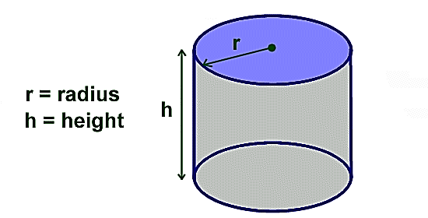

**Volume of a Cylinder**

Volume = Base Area ∙ Height

V = BH

V = πr2H

This is the same formula we used for a prism. But, with a cylinder

the base is a _____________________.

**Example 1**: Find the volume of the cylinder below. Leave your answer in terms of π.

TP1005ta03.jpg                                                 0002249F
Blue Sky Dome                  ABA78158:

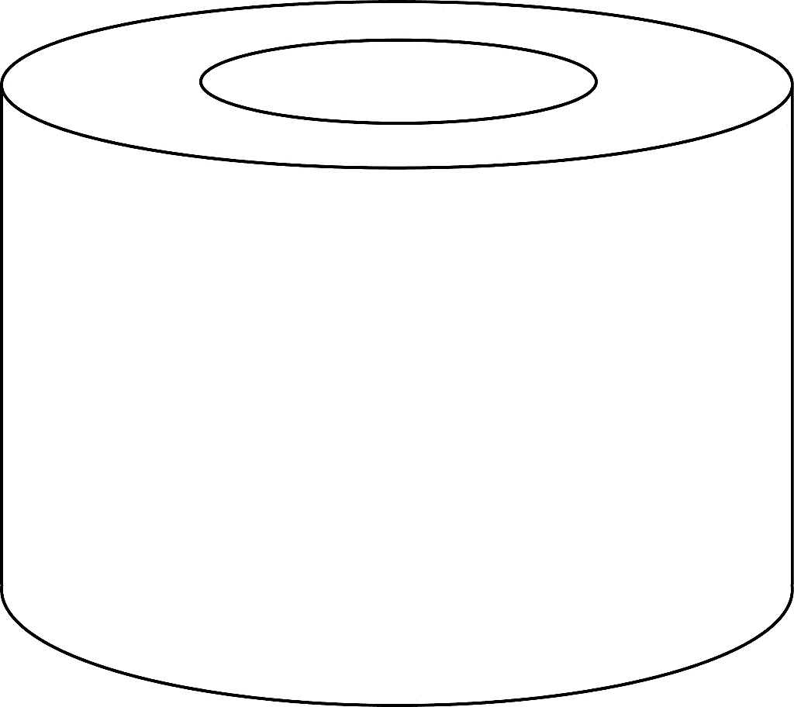**Example 2:** Find the volume of the remaining figure if the inner cylinder has been cut out of the larger one. The larger cylinder has a diameter of 10 in and the inner cylinder has a radius of 4 in. The height of each is 8 in.

**TP1005ta04.jpg                                                 0002249F
Blue Sky Dome                  ABA78158:Example 3:** Find the volume of the composite space figure.

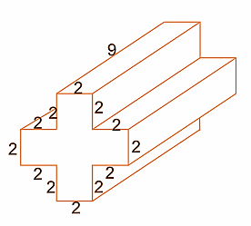**Example 4:** What is the volume of the prism?

**Example 5:** What is the volume of the container?

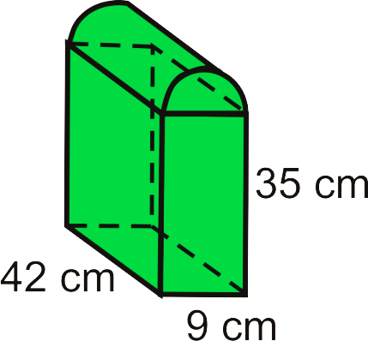

**Homework:** Practice 10 – 5 Worksheet