**Unit 3 Linear Equations Name: ______________________________**

**Day 4 Solving Systems Group Activity Date: ___________________ Hour: _____**

**Which method for solving the system of equations do you think is most appropriate?**

**Write the method you choose on the blank. Use this method to solve the system.**

**ONLY use the graph if you choose the graphing method to solve. Otherwise, leave it blank.**

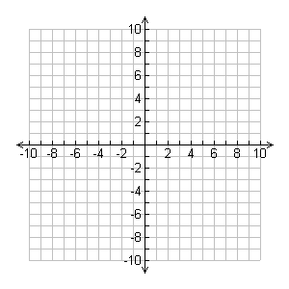**1.**   ( , ) ______________________

**2.**  ( , ) ______________________

**3.**  ( , ) ______________________

**4. The Stevenson Drama Club hosted James and the Giant Peach. The club charged $3 per child and $5 per adult. A total of 374 tickets were sold, raising $1,524. How many child and how many adult tickets were sold?**

|  |  |
| --- | --- |
| 1. **Define your variables** | 1. **Write a system of equations.** |
| 1. **Solve the system** | |

**5. A class of 195 students went on a field trip to Cedar Point. They took 7 vehicles, some cars and some buses. Find the number of cars and the number of buses they took if each car holds 5 students and each bus hold 45 students.**

|  |  |
| --- | --- |
| 1. **Define your variables** | 1. **Write a system of equations.** |
| 1. **Solve the system** | |