**Geometry Unit 7 Review Assignment Day 3 – 4.**

**Part A: Write the volume formulas for the following figures.**

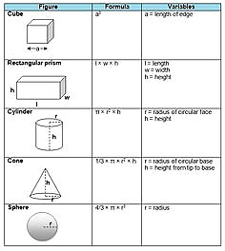

**Part B: Compute the volume of the following figures. Leave answers in terms of π.**

TT_PH_EN_MA_GM_2004_10/PH_MA_GM04_10_99_574_3.gifTT_PH_EN_MA_GM_2004_10/PH_MA_GM04_10_99_574_2.gif1. 2.

TT_PH_EN_MA_GM_2004_10/PH_MA_GM04_10_99_575_1.gif

TT_PH_EN_MA_GM_2004_10/PH_MA_GM04_10_99_574_4.gif3. 4.

**Part C: Complete the following exercises (PH CH 10 Test).**

**Use a separate sheet of paper to show work.**



(Trace on other paper to complete #3)



**Find the volume of each figure. Round answers to the nearest tenth.**

