Unit 1 Quiz Day Practice Name: _______________________________
Date: ___________________ Hour: _____
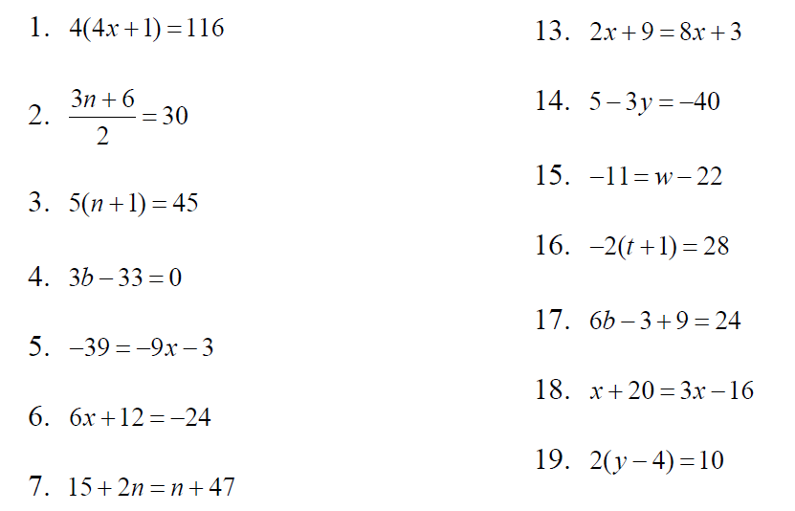
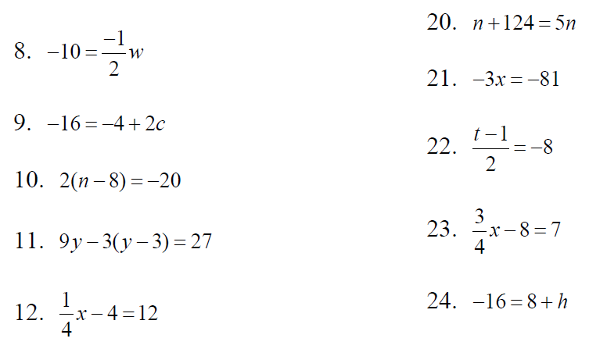
Solve each equation. Show all work on a separate sheet of paper for full credit.

