**Unit 5: Right Triangle Trigonometry Name:_________________________**

**Day 3: 30°- 60°- 90° Triangle Investigation Date: _______________ Hour: _____**

The 30°-60°-90° right triangle is formed by dividing an equilateral triangle in half. The 30-60-90 right triangle has special relationships among its side lengths. In this investigation, you will discover these special relationships.

Investigation:

Let’s start by using a little deductive thinking to reveal a useful relationship within 30-60-90 triangles. Triangle ABC is equilateral and 𝐶𝐷̅̅̅̅ is an altitude.

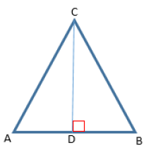

1. What are 𝑚∠𝐴 and 𝑚∠𝐵?
2. What are 𝑚∠𝐴𝐶𝐷 and 𝑚∠𝐵𝐶𝐷?
3. What are 𝑚∠𝐴𝐷𝐶 and 𝑚∠𝐵𝐷𝐶?
4. Is Δ𝐴𝐷𝐶≅Δ𝐵𝐷𝐶? Why?
5. Is 𝐴𝐷̅̅̅̅ ≅ 𝐵𝐷̅̅̅̅ ? Why?
6. Notice the altitude divides the equilateral triangle into two right triangles with acute angles that measure 30˚ and 60˚. Look at just one of the 30-60-90 triangles, say Δ𝐴𝐷𝐶. How do AC and AD compare? (hint: remember it is an equilateral triangle and a perpendicular line)

Let’s see what else you can discover….find the length of the indicated side using the conjecture you just made above.

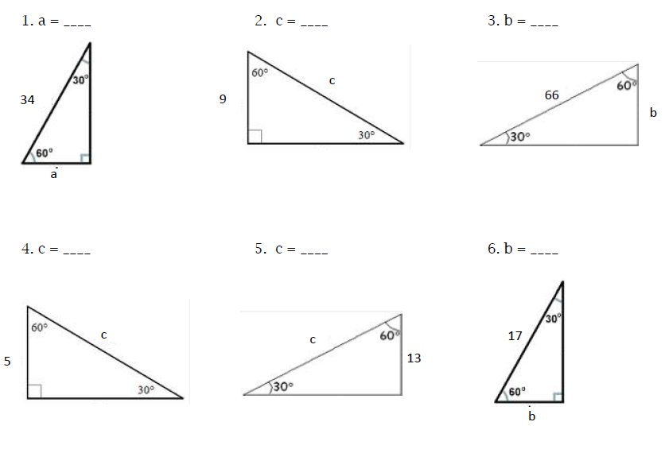



Now use the comparison you made in the last investigation and **the Pythagorean Theorem** to find the length of each side. Be sure to simplify all radicals

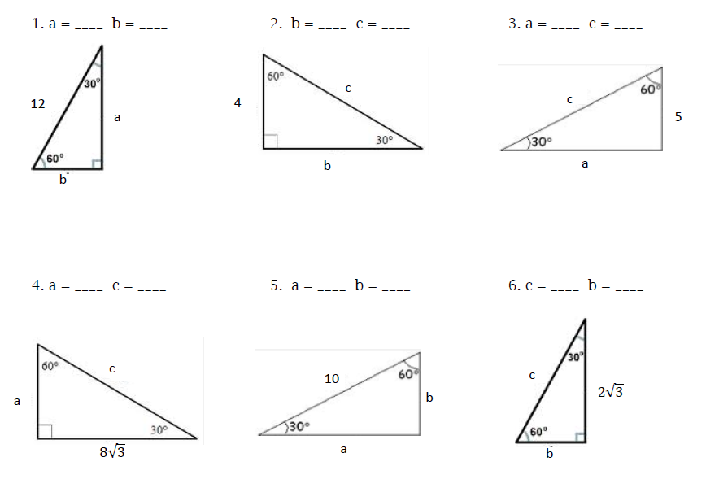

You should notice a pattern in your answers. Combine your observations and make a conjecture. Fill in the blanks in terms of x.

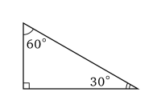

In a 30-60-90 triangle, if the shorter leg has length x,

then the longer leg has length _______

and the hypotenuse has length ___________.

**Homework: Unit 5 Day 3 Worksheet**